**SQL MURDER MYSTERY ASSIGNMENT**

Karnika A

2237038

2MAECO

Date of Submission: 29/03/23  
  
Submitted to  
Mr. Abdul MR



MA APPLIED ECONOMICS

DEPARTMENT OF ECONOMICS

CHRIST (DEEMED TO BE UNIVERSITY)

March 2023

Background:

A crime has taken place and the detective needs your help. The detective gave you

the crime scene report, but you somehow lost it. You vaguely remember that the

crime was a **​murder​** that occurred sometime on ​**Jan.15, 2018​** and that it took place

in ​**SQL City​**. Start by retrieving the corresponding crime scene report from the

police department’s database.

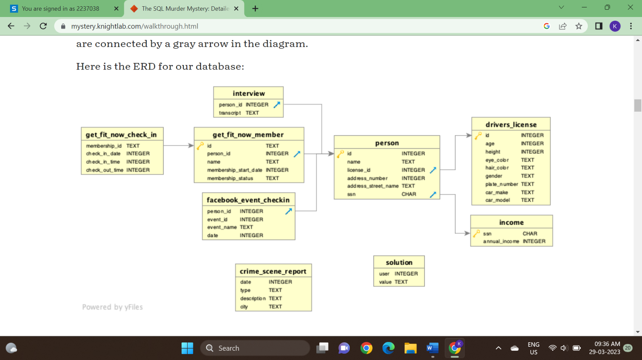

1. To view the whole table from the database:

SELECT *

FROM sqlite_master

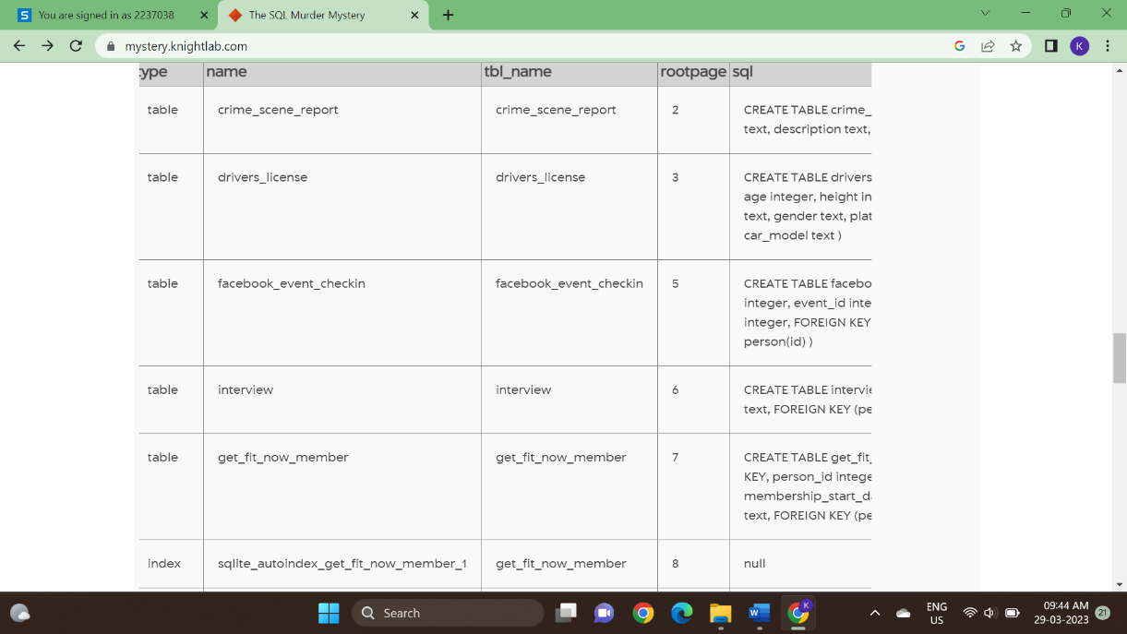

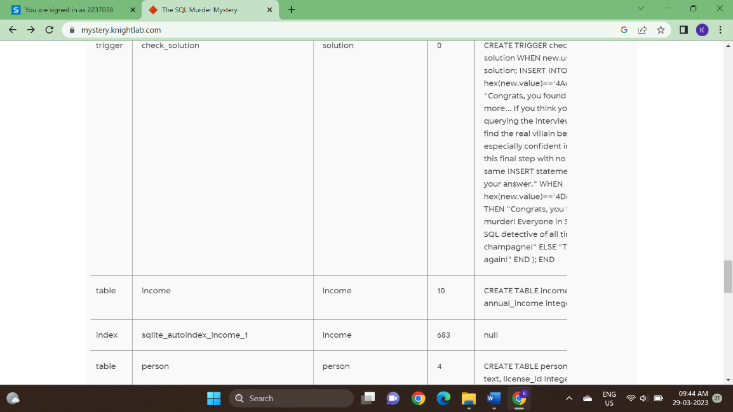

1. To know the various sub tables from the main table:

SELECT name

FROM sqlite_master

WHERE type = 'table'

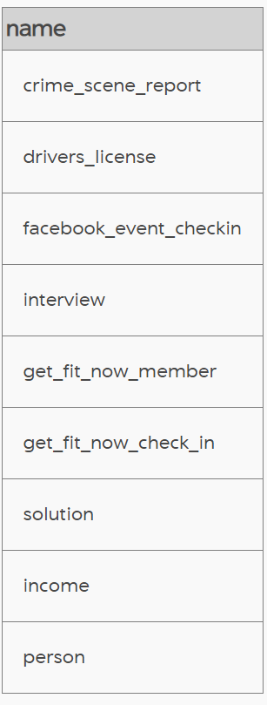

1. To get the crime scene report:

SELECT *

FROM crime_scene_report LIMIT 10

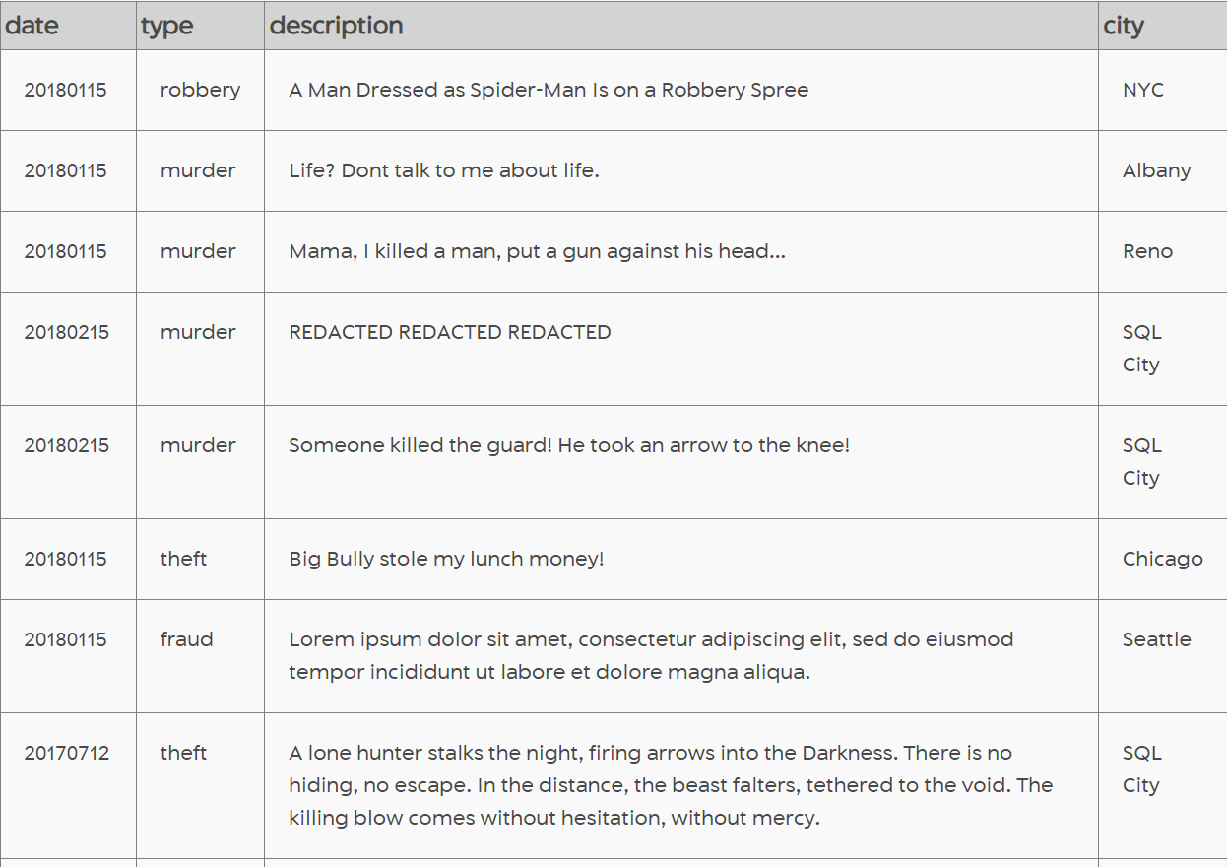

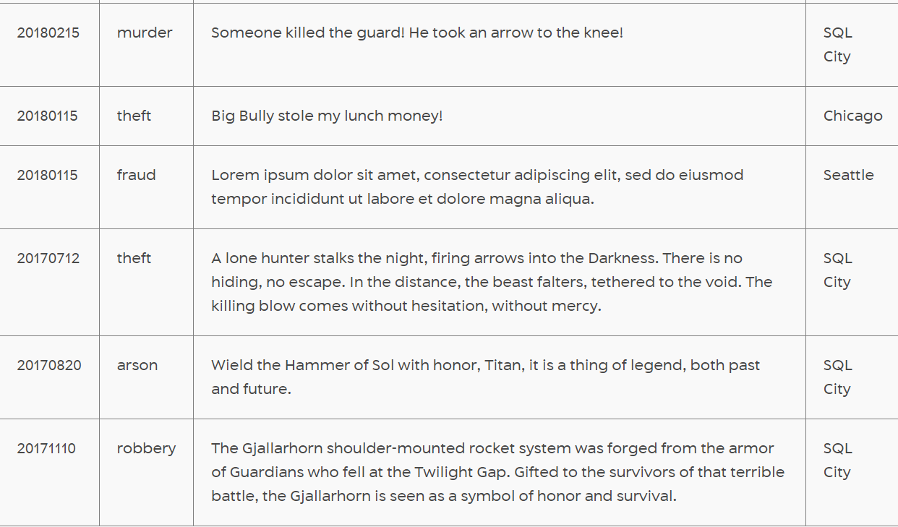

We are given that the crime is murder and has happened in SQL City.

1. To know the murder with respect to SQL City:

SELECT date, type, description, city

FROM crime_scene_report

WHERE type = ‘murder’ AND city = ‘SQL City’

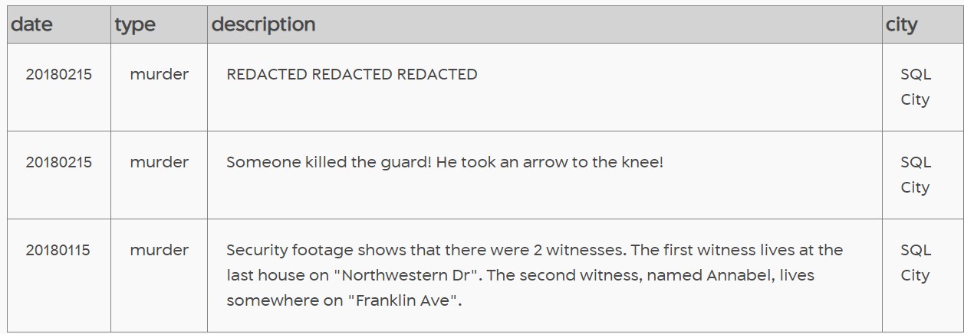

1. To get to know the names of the witnesses:

SELECT name, address_street_name, address_number, license_id

FROM person p

JOIN drivers_license dl

ON p.license_id = dl.id

WHERE address_street_name = "Northwestern Dr"

ORDER BY address_number DESC LIMIT 1

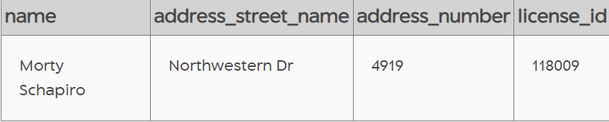

1. SELECT name, address_street_name, address_number, license_id

FROM person p

JOIN drivers_license dl

ON p.license_id = dl.id

WHERE address_street_name = "Franklin Ave" and

name LIKE "Annabel%"

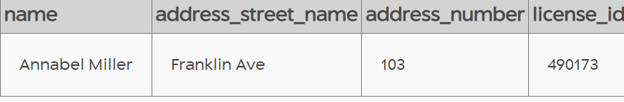

1. To find the interview transcript of the witnesses:

SELECT person.name, interview.transcript

FROM person

JOIN interview

ON person.id = interview.person_id

WHERE person.id = 14887 OR person.id = 16371

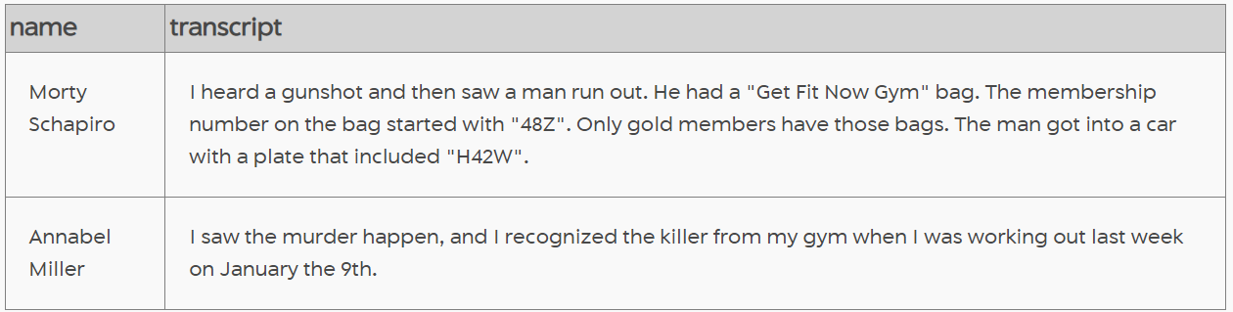

1. Finding the killer:

SELECT get_fit_now_member.name, get_fit_now_check_in.membership_id, get_fit_now_check_in.check_in_date

From get_fit_now_member

JOIN get_fit_now_check_in

ON get_fit_now_member.id = get_fit_now_check_in.membership_id

WHERE membership_status = 'gold' AND check_in_date = 20180109

AND membership_id LIKE '48Z%'

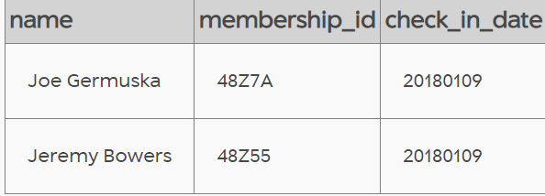

**FINDING 1:**

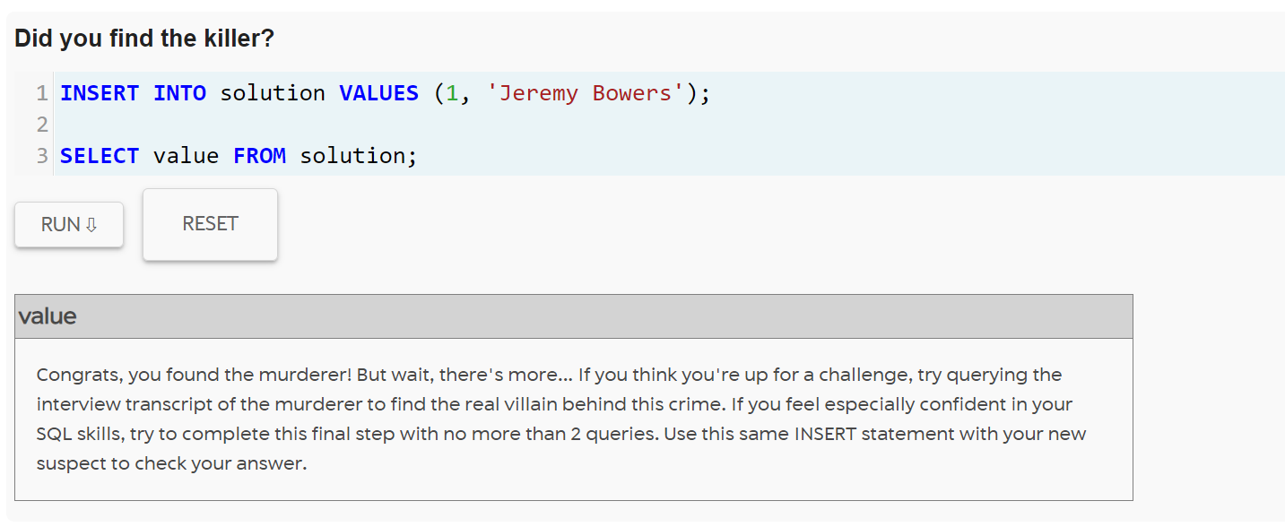

1. To get the interview transcript of the killer:

SELECT person.name, interview.transcript

FROM person

JOIN interview

ON person.id = interview.person_id

WHERE name = ‘Jeremy Bowers’

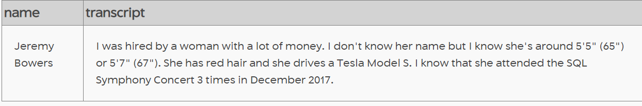

1. To find who made the killer do the murder:

SELECT name, annual_income as income, gender, eye_color as eyes, hair_color as hair, car_model as car

FROM income i

JOIN person p

ON i.ssn = p.ssn

JOIN drivers_license dl

ON p.license_id = dl.id

WHERE income > 400000

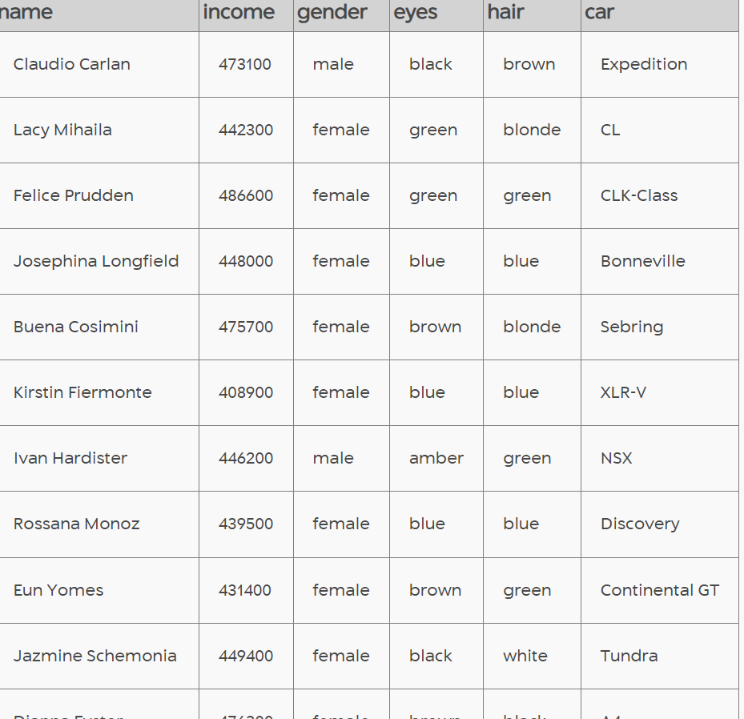

The above list did not satisfy the criteria mentioned by Jeremy Bowers, so we try to find the brains behind the murder using another code.

1. SELECT name, annual_income as income, gender, eye_color as eyes, hair_color as hair,

car_model as car

FROM income i

JOIN person p

ON i.ssn = p.ssn

JOIN drivers_license dl

ON p.license_id = dl.id

WHERE gender = "female" and hair = "red" and car like "%Model S"

ORDER BY annual_income DESC

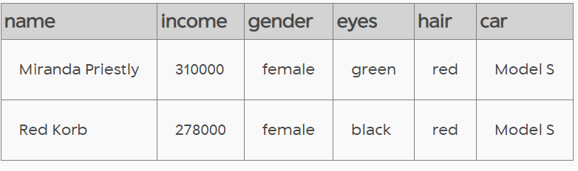

**FINDING 2:**

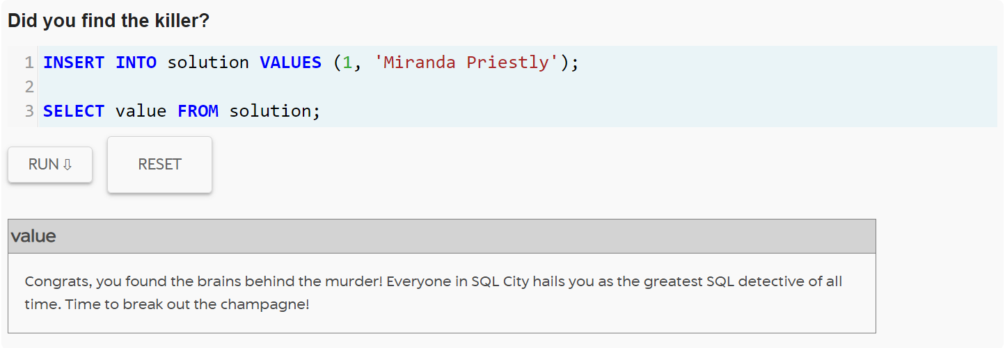

**CONCLUSION**: Jeremy Bowers is the murderer, and he was made to do by Miranda Priestly in the SQL City.